**PF Lab # 11**

**Name: Ali Rooman**

**Roll No: 24K-0792**

Q1. Write a C program to define a structure Book that contains the following fields:

title (a string of up to 100 characters)

author (a string of up to 50 characters)

price (a float)

Additionally, define another structure Library that contains:

library_name (a string of up to 50 characters)

total_books (an integer)

books[] (an array of Book structures to store information of the books in the library)

Write a function to input details of multiple books and display the details of the library, including the books it contains. Use nested structures to organize the data.

|  |
| --- |
| #include <stdio.h>  #include <string.h>  struct Book {  char title[100];  char author[50];  float price;  };  struct Library {  char name[50];  int totalBooks;  struct Book bookCollection[100];  };  void inputLibraryDetails(struct Library *library) {  printf("Enter library name: ");  fgets(library->name, sizeof(library->name), stdin);  library->name[strcspn(library->name, "\n")] = '\0';  printf("Enter total number of books: ");  scanf("%d", &library->totalBooks);  getchar();  for (int i = 0; i < library->totalBooks; i++) {  printf("\nEnter details for book %d:\n", i + 1);  printf("Title: ");  fgets(library->bookCollection[i].title, sizeof(library->bookCollection[i].title), stdin);  library->bookCollection[i].title[strcspn(library->bookCollection[i].title, "\n")] = '\0';  printf("Author: ");  fgets(library->bookCollection[i].author, sizeof(library->bookCollection[i].author), stdin);  library->bookCollection[i].author[strcspn(library->bookCollection[i].author, "\n")] = '\0';  printf("Price: ");  scanf("%f", &library->bookCollection[i].price);  getchar();  }  }  void displayLibraryDetails(const struct Library *library) {  printf("\nLibrary Name: %s\n", library->name);  printf("Total Books: %d\n", library->totalBooks);  for (int i = 0; i < library->totalBooks; i++) {  printf("\nBook %d:\n", i + 1);  printf("Title: %s\n", library->bookCollection[i].title);  printf("Author: %s\n", library->bookCollection[i].author);  printf("Price: %.2f\n", library->bookCollection[i].price);  }  }  int main() {  struct Library;  inputLibraryDetails(&library);  displayLibraryDetails(&library);  return 0;  } |

OUTPUT

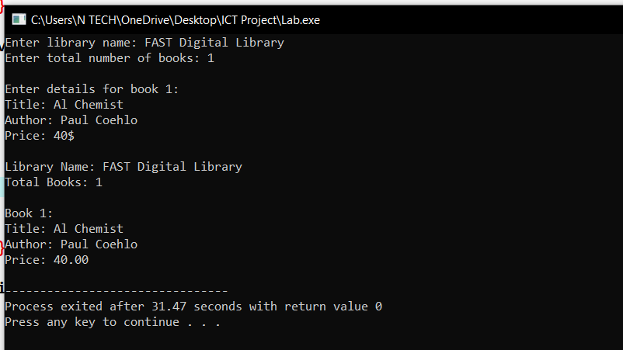

Q2 Program to save library data into a file

|  |
| --- |
| #include <stdio.h>  #include <string.h>  struct Book {  char title[100];  char author[50];  float price;  };  struct Library {  char name[50];  int totalBooks;  struct Book bookCollection[100];  };  void inputLibraryDetails(struct Library *library) {  printf("Enter library name: ");  fgets(library->name, sizeof(library->name), stdin);  library->name[strcspn(library->name, "\n")] = '\0';  printf("Enter total number of books: ");  scanf("%d", &library->totalBooks);  getchar();  for (int i = 0; i < library->totalBooks; i++) {  printf("\nEnter details for book %d:\n", i + 1);  printf("Title: ");  fgets(library->bookCollection[i].title, sizeof(library->bookCollection[i].title), stdin);  library->bookCollection[i].title[strcspn(library->bookCollection[i].title, "\n")] = '\0';  printf("Author: ");  fgets(library->bookCollection[i].author, sizeof(library->bookCollection[i].author), stdin);  library->bookCollection[i].author[strcspn(library->bookCollection[i].author, "\n")] = '\0';  printf("Price: ");  scanf("%f", &library->bookCollection[i].price);  getchar();  }  }  void saveLibraryToFile(const struct Library *library, const char *filename) {  FILE *file = fopen(filename, "wb");  if (file == NULL) {  printf("Error opening file for writing.\n");  return;  }  fwrite(library, sizeof(struct Library), 1, file);  fclose(file);  printf("Library data saved to file.\n");  }  void loadLibraryFromFile(struct Library *library, const char *filename) {  FILE *file = fopen(filename, "rb");  if (file == NULL) {  printf("Error opening file for reading.\n");  return;  }  fread(library, sizeof(struct Library), 1, file);  fclose(file);  }  void displayLibraryDetails(const struct Library *library) {  printf("\nLibrary Name: %s\n", library->name);  printf("Total Books: %d\n", library->totalBooks);  for (int i = 0; i < library->totalBooks; i++) {  printf("\nBook %d:\n", i + 1);  printf("Title: %s\n", library->bookCollection[i].title);  printf("Author: %s\n", library->bookCollection[i].author);  printf("Price: %.2f\n", library->bookCollection[i].price);  }  }  int main() {  struct Library library;    inputLibraryDetails(&library);  saveLibraryToFile(&library, "library.txt");  struct Library loadedLibrary;  loadLibraryFromFile(&loadedLibrary, "library.txt");  displayLibraryDetails(&loadedLibrary);  return 0;  } |

OUTPUT

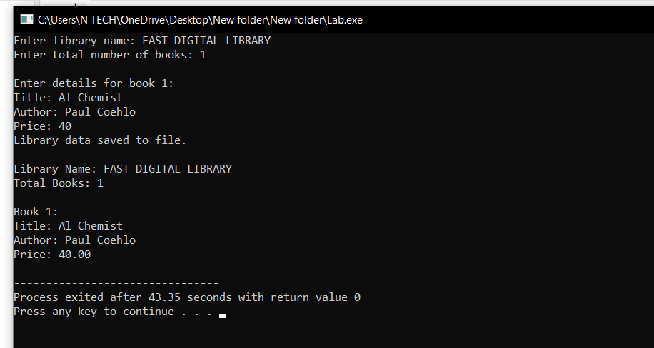

Here a file named library is created and inside it data is stored

